**P250/1**

**GEOGRAPHY**

**(PHYSICAL GEOGRAPHY)**

**Paper 1**

**3 HOURS**

**SET 3**

**GOOD SHEPHERD HIGH SCHOOL- BWEYOGERERE**

**UGANDA ADVANCED CERTIFICATE OF EDUCATION**

**INTERNAL MOCK EXAMINATIONS 2022**

**S.6 – GEOGRAPHY PAPER 1**

**(PHYSICAL GEOGRAPHY)**

**TIME: 3 HOURS**

**INSTRUCTIONS TO CANDIDATES**

1. *This paper consists of* ***three*** *sections: A, B and C.*
2. *Answer* ***FOUR*** *questions.*
3. *Section A is compulsory.*
4. *At least* ***ONE*** *question should be answered from section B and* ***ONE*** *question from section C.*
5. *Credit will be given for use of relevant sketch maps, diagrams and specific examples studied in the field.*
6. *Any additional questions attempted will* ***not*** *be marked.*

SECTION: A

**Questions 1 and 2 are compulsory**

**COMPULSORY MAPWORK QUESTION.**

1. Study the 1;50,000(UGANDA) MASINDI map extract, part of sheet 39/3 series Y732,Edition 1.USD and answer the questions that follow;
2. (i) State the grid reference of the borehole south east of Ikoba***.(1 mark)***

(ii) Identify the physical feature found at grid reference 463783. ***(1 mark)***

1. Determine the de-tour index of the dry weather road from Bujenje junction (GR 487768) westwards to Budongo (GR 430822). ***(2 marks).***
2. Draw a relief section of the area between GR 440760 and GR 500820 and on it marks and name the following;

(i) Relief features

(ii)Land use activities

(iii) Drainage features ***(09 marks)***

1. With evidence, describe the problems faced in Masindi town ***(04 marks)***
2. (i) Describe the land use activities in the area on the map extract ***(04 marks)***

(ii) Explain the relationship between drainage and land use on the map extract. ***(04 marks)***

1. Study the photograph below and answer the questions that follow;

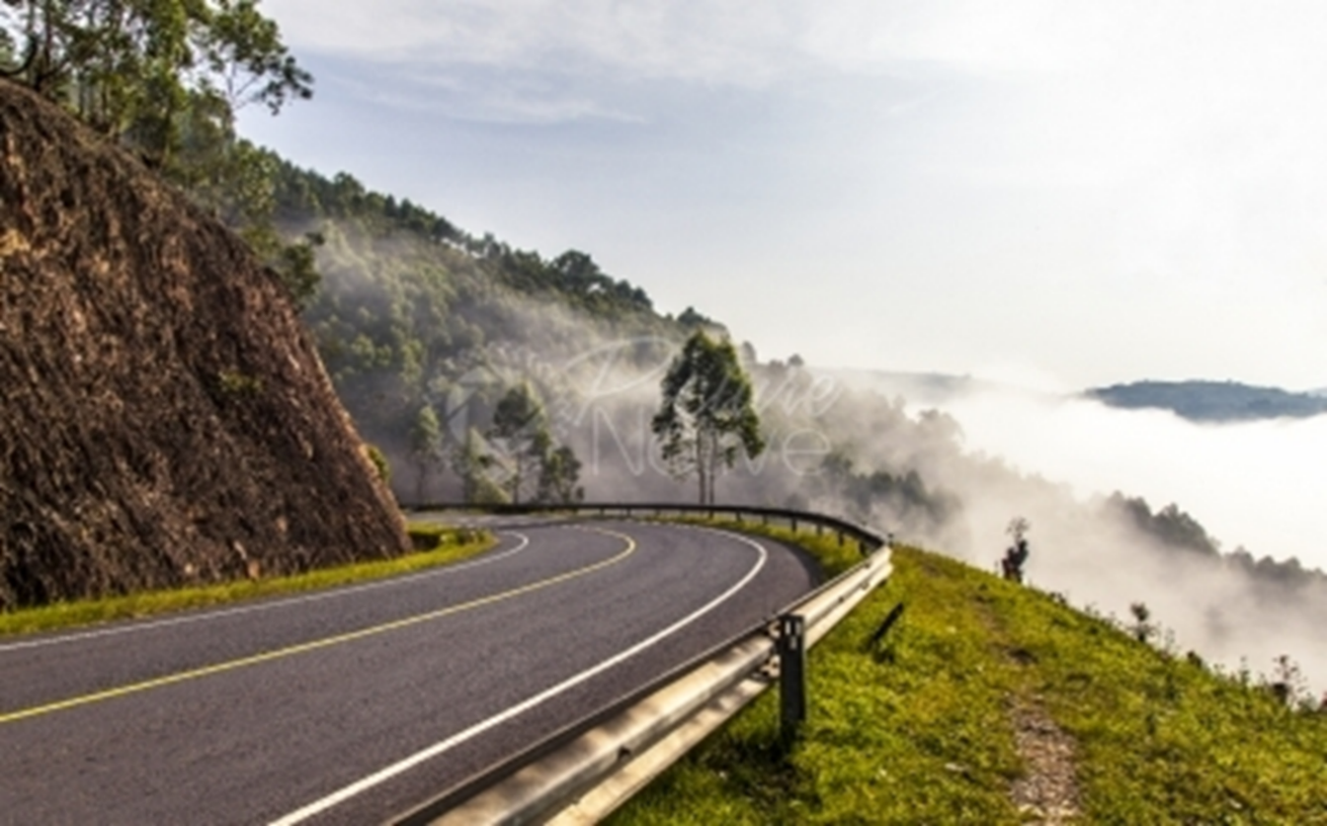

1. Draw a landscape sketch and on it mark and label any;
2. Two relief features
3. Two landuse types (***07 marks***)
4. (i) Identify the weather condition depicted in the right middle ground of the photograph (**01 *mark****)*

(ii). Account for the occurrence of the climatic condition identified in b (i) above. (***05 marks***)

1. (i). Describe the problems faced by people living in the area shown in the photograph *(****06 marks****)*

(ii). Outline the steps being taken to solve the problems described in C (i) above. *(****03 marks****)*

1. Giving reasons for your answer, suggest an area in East Africa where the photograph could have been taken. (***03 marks***)

**SECTION B**

Answer one question from this section.

1. Account for the occurrence of landslides in East Africa. ***(25 marks)***.
2. (a) Distinguish between Long Profile and Cross Profile of a river valley***. (06 marks)***

(b)Examine the formation of features in the senile stage of a river Profile***.***

***(19marks).***

**5**. Explain the influence of tectonic processes on lake formation in East Africa***. (25 Marks)\***

**SECTION C**

Answer one question from this section.

**6.** (a) Describe how temperature is measured and recorded at a weather station. ***(10 marks)***

(b)To what extent has the position of the overhead sun influenced temperature variations in East Africa***. (15 marks)***

**7**. Account for the destruction of tropical rainforest Vegetation in east Africa***. (25 marks)***

**8**. To what extent has the parent rock influenced the development of soil types in East Africa***. (25 marks)***

**END**